R programming Language
for Data Analytics.

Learning Objective

- Setting up the computers.
- Investigation how to import datasets into R.
- Installing packages and loading library.
- How to get the datasets.
- Investigate how to run Descriptive Analysis in R.

Resources you will need.

- R-Studio installation and RStudio cloud
- Jupyter notebook for R (Project Jupyter | Try Jupyter)
- Any other R IDE.
- Datasets are in each library.

Install R and R studio and open the interface.

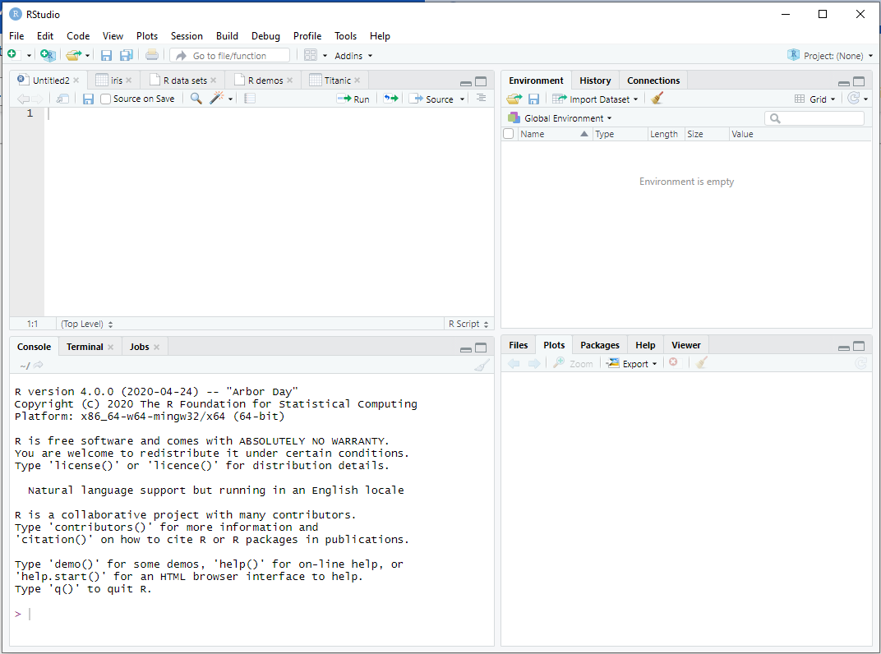

Setting up the folder/Directory >>> see below

.
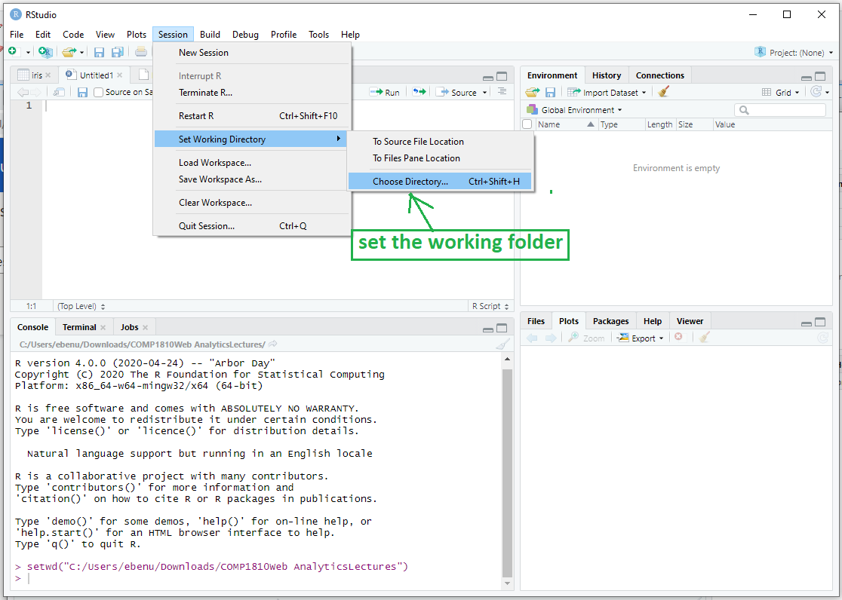

Code to set working directory [This does not work on the online system as at the time of this tutorial]

setwd("C:/Users/ebenu/Downloads/COMP1810Web AnalyticsLectures/Lecture Slide 1810/Practicals-Weekly")

Task 1 Learn how to import Dataset into R

Download the three datasets “data”, “hflights” and “mpg” in the module home page of today’s lecture and import them into R
[You must investigate this using the web]

Importing data into R
Every concept must be investigated using google

For example
  - How to import excel file in R
  - How to import text file in R

Reading Data Files
Reading or importing data into RStudio is quite simple and also s
Reading a CSV File
Using the code
data <- read.csv(file="data.csv", header=TRUE, sep=",");

Below is the data.csv file that will be loaded into RStudio for this practical session

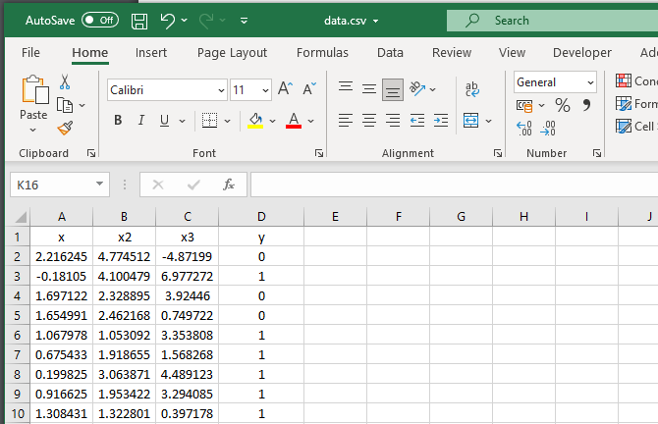

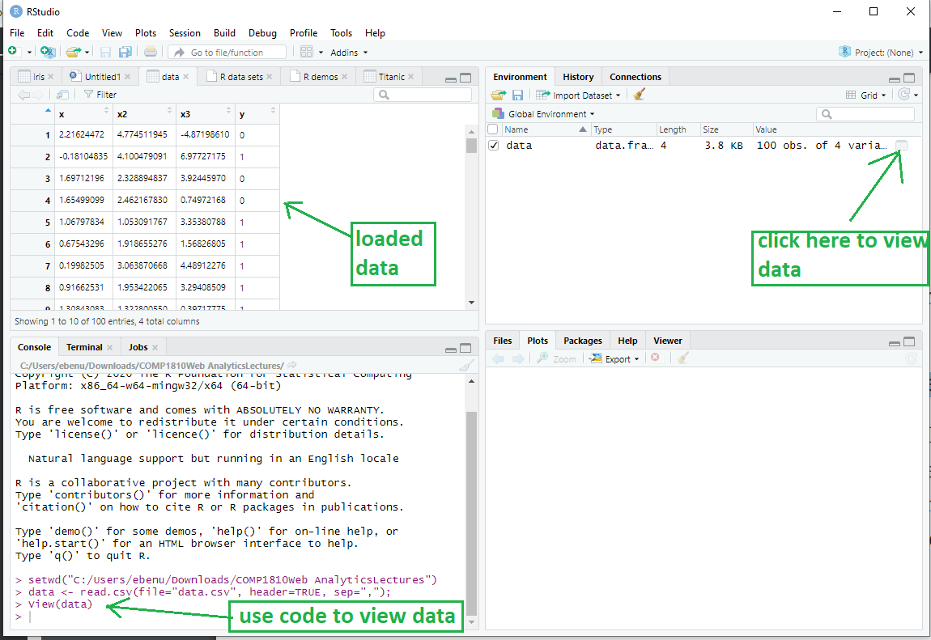

Read in Excel file
If the file is in excel use below code
data <- read.xlsx(file="data.xlsx", 1);
file is the location of the Excel file. 1 refers to sheet number 1.

///////////////////////////////////////////////////////////////////////////////////////////////////////////////////////////////

See the data by using >>>>>>data;
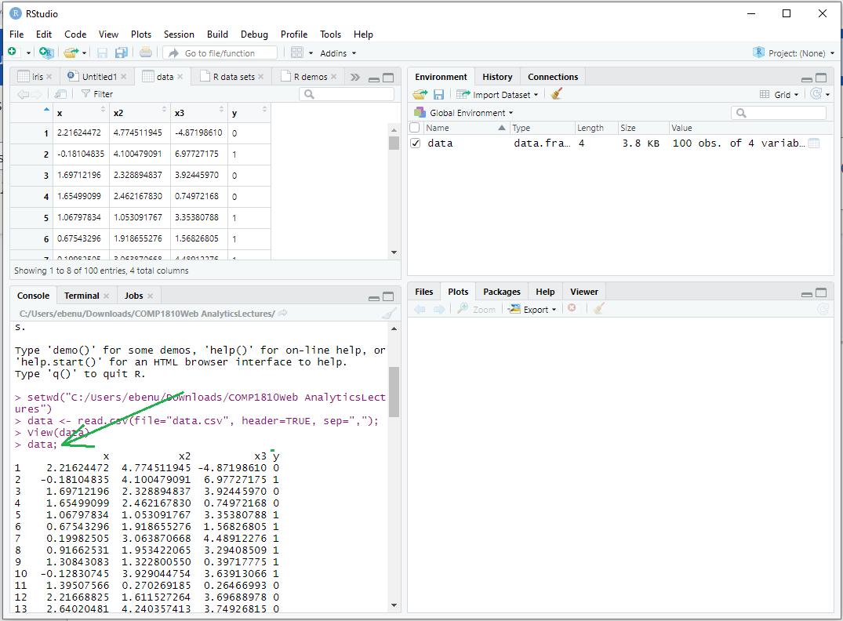

Selecting Data
You can select a few columns “x” and “x3” from the data using a vector:
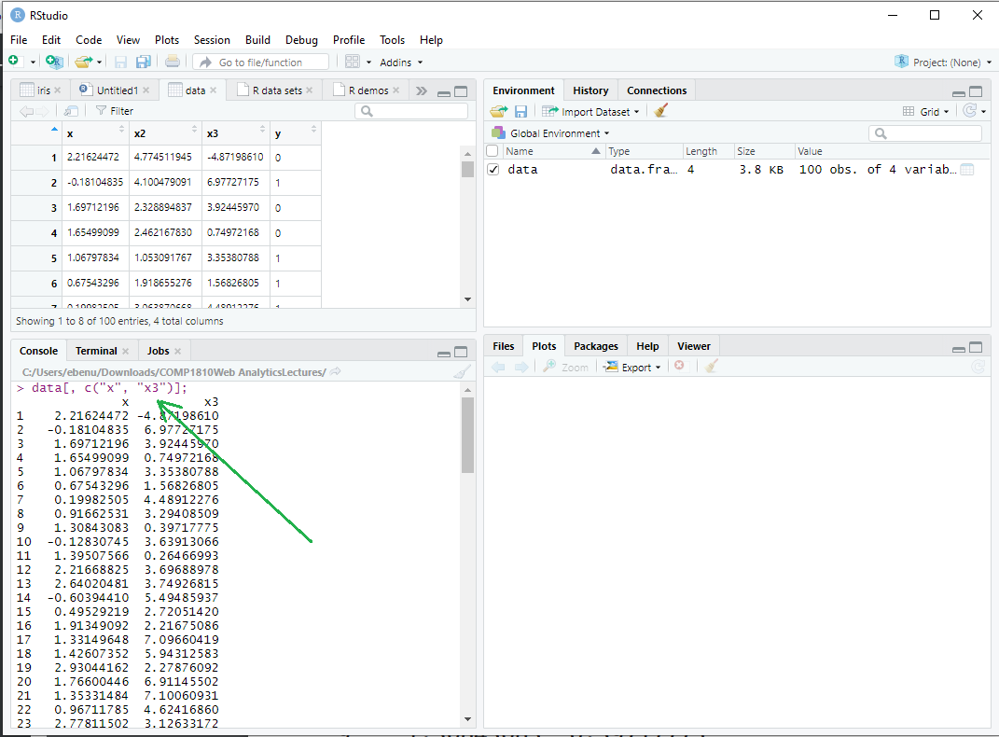

Select only x ad x3 from the data

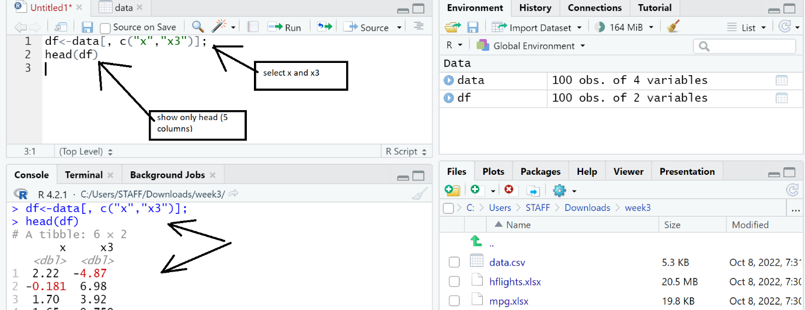

In the above you can also use the select() function in dplyr package to achieve the same thing

Task 2 Learn how Install packages and loading the library.

Every concept must be investigated using google

For example
  - How to install and load dplr in r

Notice that dplr is a package although is inside bigger package called “tidyverse”
[tidyverse is the almighty package for data analytics]
Syntax:
install.packages("packagename")

install.packages("dplr ") # this will install dplr package

install.packages("tidyverse ") # this will install tidyverse package

install.packages("vioplot") # this will install vioplot package
install.packages(" babynames ")
Install more than one package
install.packages(c("vioplot", "MASS")) # this will install vioplot and MASS package
To remove package
remove.packages("vioplot") # this will remove vioplot package

Loading a package

Installing packages is not enough, you must load them to be able to use them.

library(dplyr)# this will load dplr package
library(babynames) # this will load babynames package

To check all function in a loaded package

ls("package:babynames")
ls("package:dplyr")

How to get the datasets.
- Most data set may be provided by your tutor.
- All packages have datasets associated with it, you will be shown how to access them. data()
- To list all data in a particular package eg ggplot2
try(data(package = "ggplot2") )

- You may download dataset from University of California datasets from link https://archive.ics.uci.edu/ml/datasets.php
- You may download dataset from Kaggle link. https://www.kaggle.com/datasets
- Others.

Online Jupyter IDE

TYPE https://jupyter.org/try

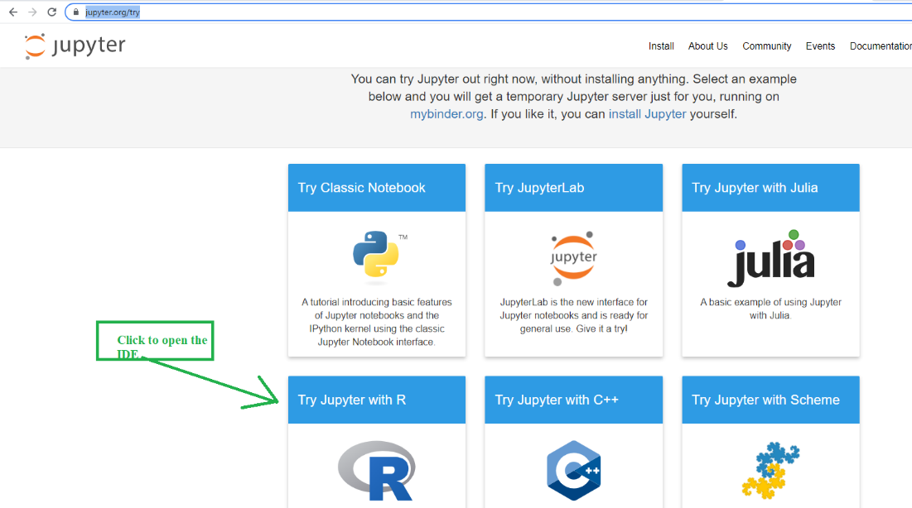
/////////////////////////////////////////////////////////////////////////////////////////////
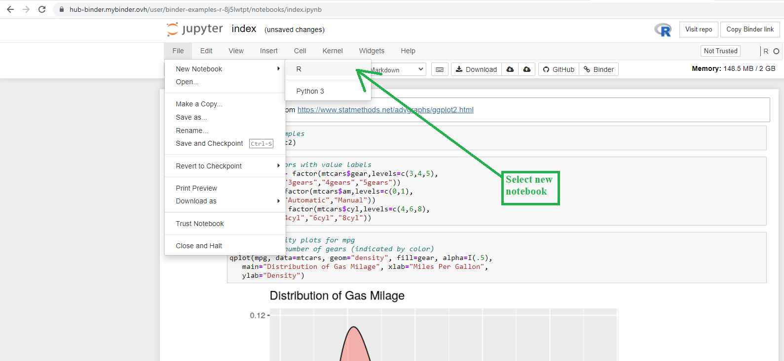
///////////////////////////////////////////////////////////////////////////////////////////////////////
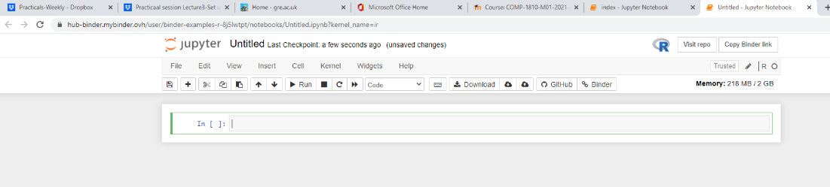

To list all data in a particular package eg ggplot2

try(data(package = "ggplot2") )

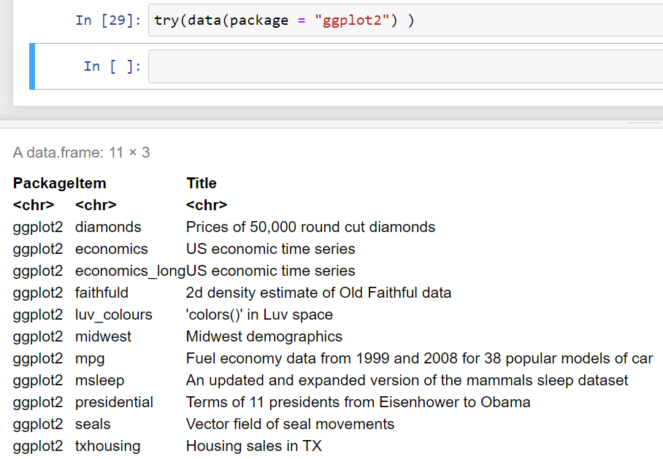

Getting Help

To get help with a function, datasets etc use

Help(datasets) or Help(function) or ?dataset

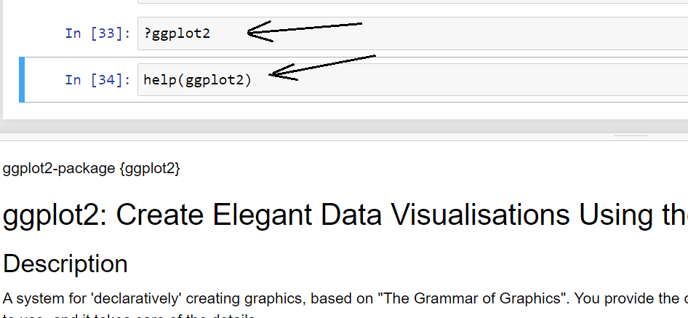

unloaded and dplyr overwrites some functions
Some function and library were overwritten by dplyr during installation of tidyverse like
nycflights13 install and load it to have access to the flight datasets used :: see below

install.packages("nycflights13")
library(nycflights13)
flights

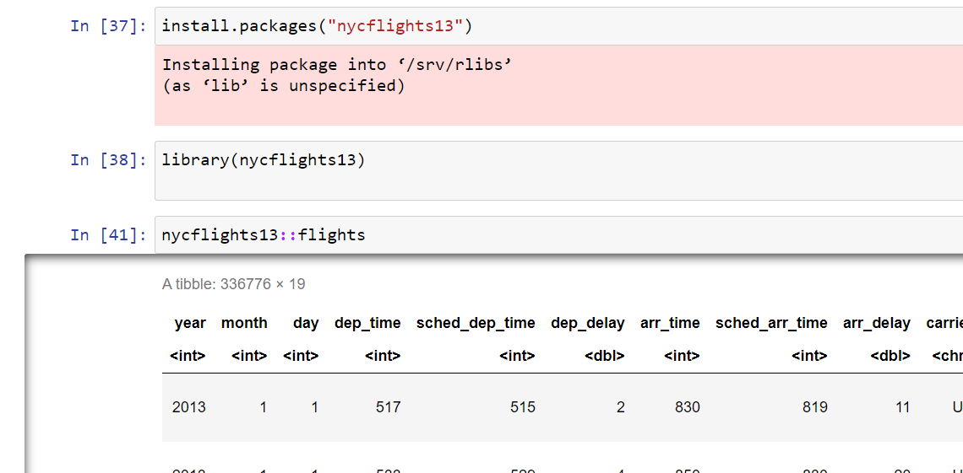

filter(flights, month == 1, day == 1)

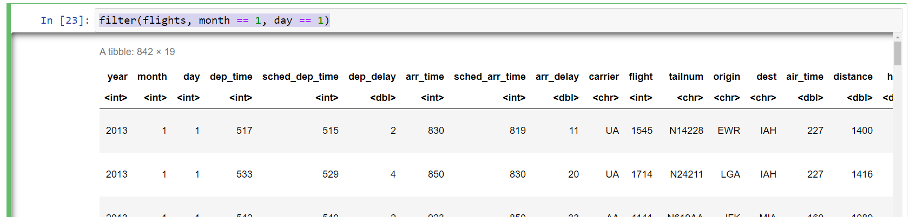

//////////////////////////////////////////////////////////////////////////////////////////////////////////////

(dec25 <- filter(flights, month == 12, day == 25))

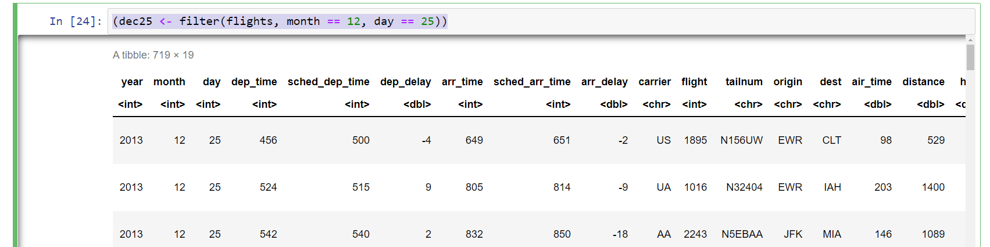

Using the dplyr

The functions of dplyr are “ssmaf”

• Pick observations by their values (filter()).
• Reorder the rows (arrange()).
• Pick variables by their names (select()).
• Create new variables with functions of existing variables (mutate()).
• Collapse many values down to a single summary (summarize()).

///////////////////////////////////////////////////////////////////////////////////////////////////////////////////////////////////////////

Comparisons Operators

R Comparisons Operators are >, >=, <=, != (not equal), and == (equal).

Find the flight departing November or December

filter(flights, month == 11 | month == 12)

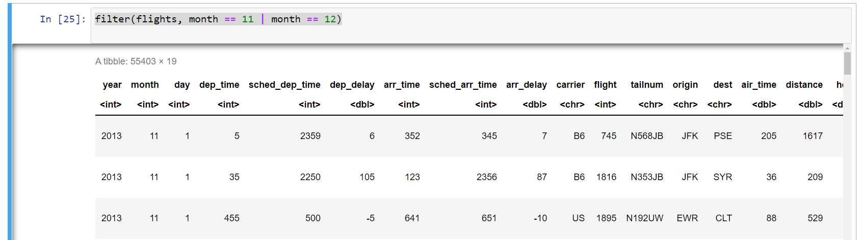
All this code produce the same result

filter(flights, month == 11 | month == 12)

nov_dec <- filter(flights, month %in% c(11, 12))

(y <- filter(flights, month == c(11, 12)))

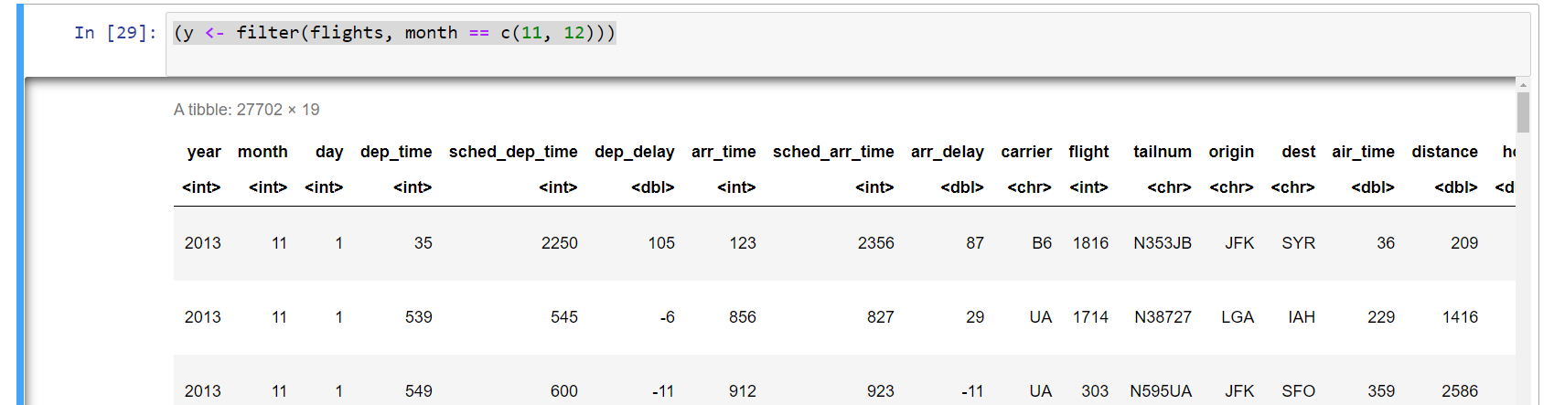

find flights that weren’t delayed (on arrival or departure) by more than two

this two code produce the same result.

filter(flights, !(arr_delay > 120 | dep_delay > 120))
filter(flights, arr_delay <= 120, dep_delay <= 120)

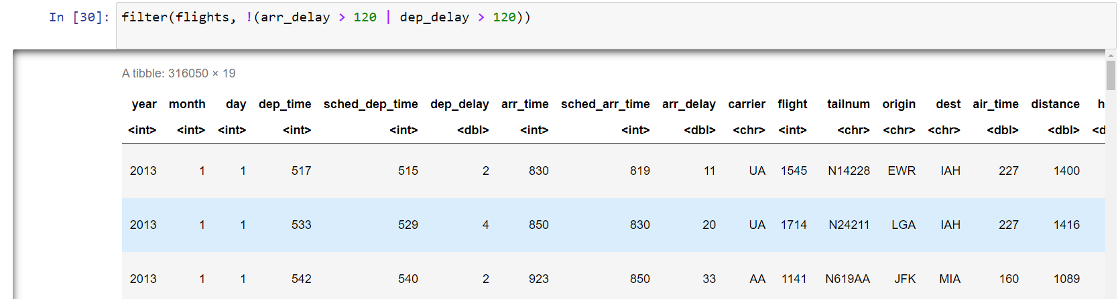

Investigate how to run Descriptive Analysis in R

- Mean
- Median
- Mode
- Variance
- Standard Deviation

///////////////////////////////////////////////////////////////////////////////////////////////////////////////////////////////////
df<-data[, c("x","x3")];
head(df)

x<-df$x

head(x)
xmean <- mean(x,na.rm = TRUE)
xmean

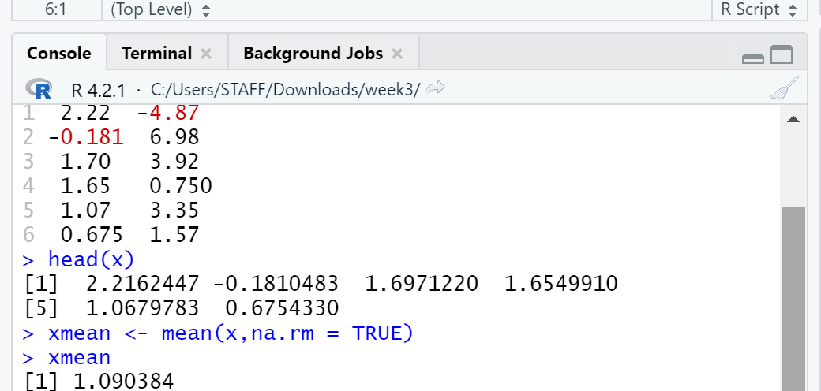

Notice how we extract a single column using

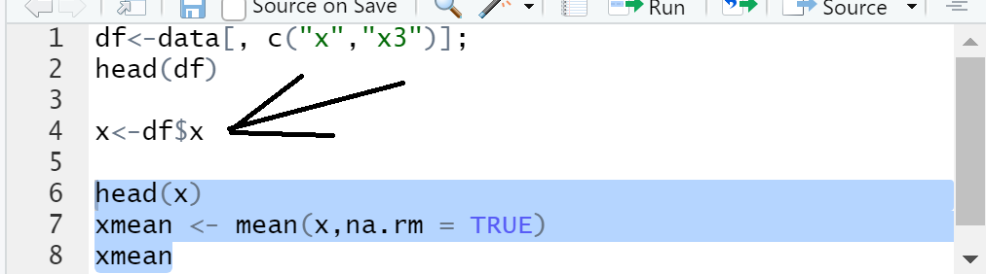

xmean <- mean(x,na.rm = TRUE)

this mean that before the mean is calculated the “NA” should be removed.

Median

xmedia<- median(x, na.rm = FALSE)
xmedia

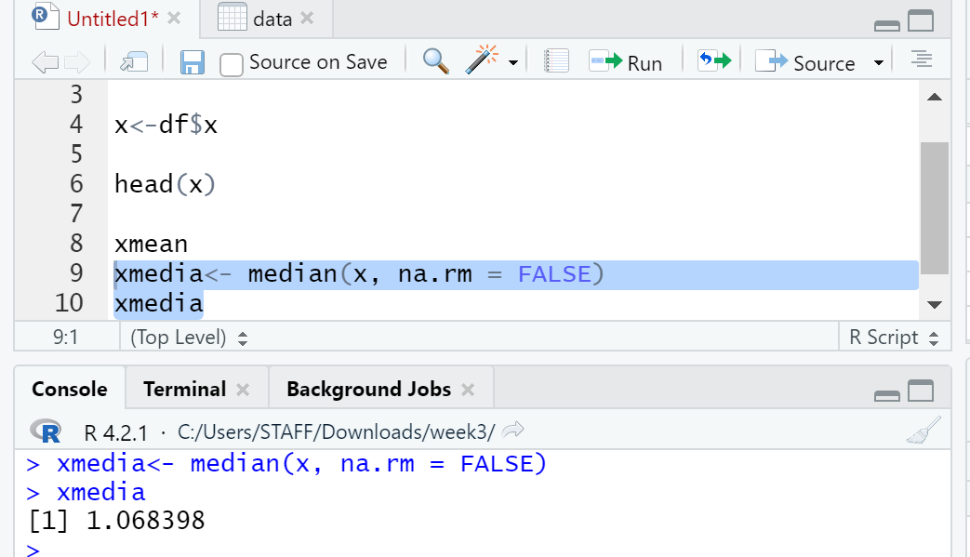

Mode

The mode is the value that has highest frequency or occurred more. Mode can have both numeric and character data.
R has no in-built function to calculate mode.

# Create the function.
getmode <- function(v) {
uniqv <- unique(v)
uniqv[which.max(tabulate(match(v, uniqv)))]
}
v<-x
# Calculate the mode using the user function.
xmode <- getmode(v)
xmode

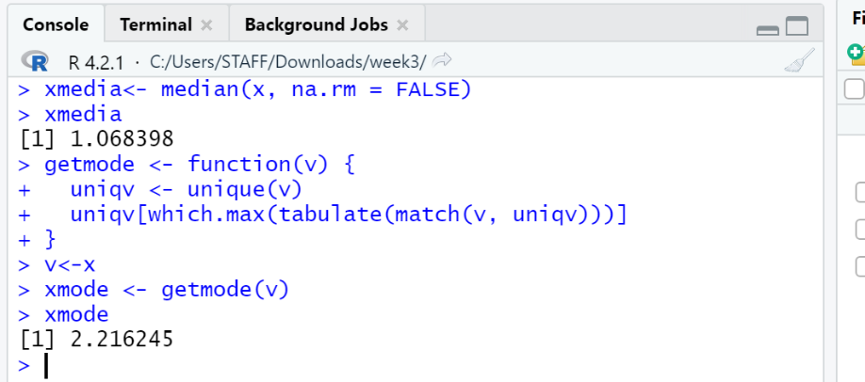

Variance
The variance is a numerical measure of how the data values is dispersed around the mean. In particular, the sample variance is defined as:
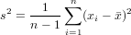
Similarly, the population variance is defined in terms of the population mean μ and population size N:
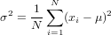

Find the sample variance of the eruption duration in the data set x3

we apply the var function to compute the sample variance
x3<-data$x3
var(x3)

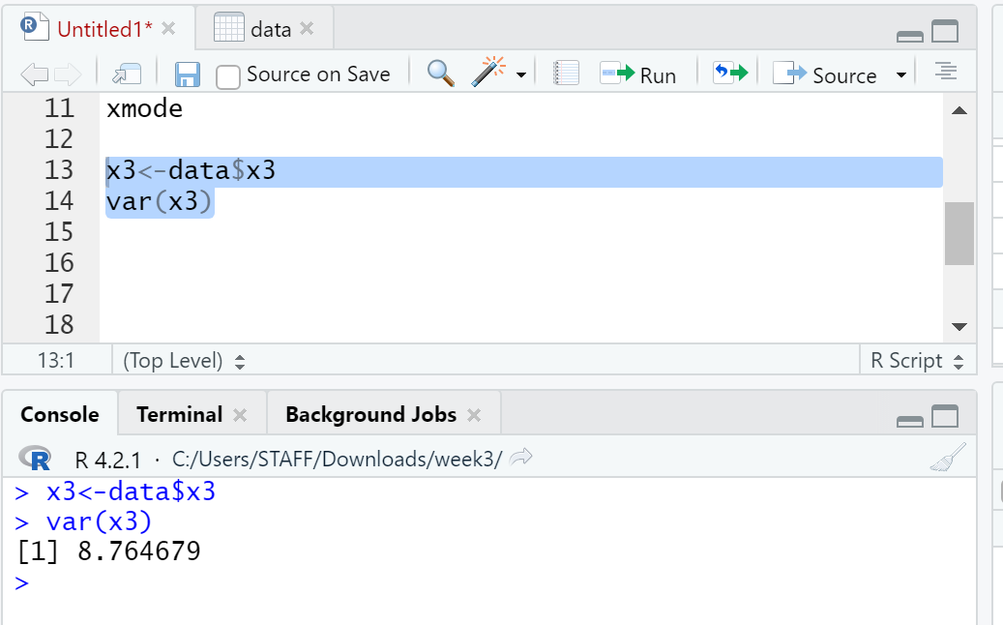

Standard Deviation
The standard deviation of an observation variable is the square root of its variance.

Problem
sd(x3)

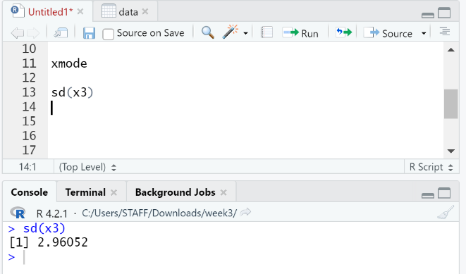
////////////////////////////////////////////////////////////////////////////////////////////////////////////////////////////////////

Using the summary functions

summary(x3)

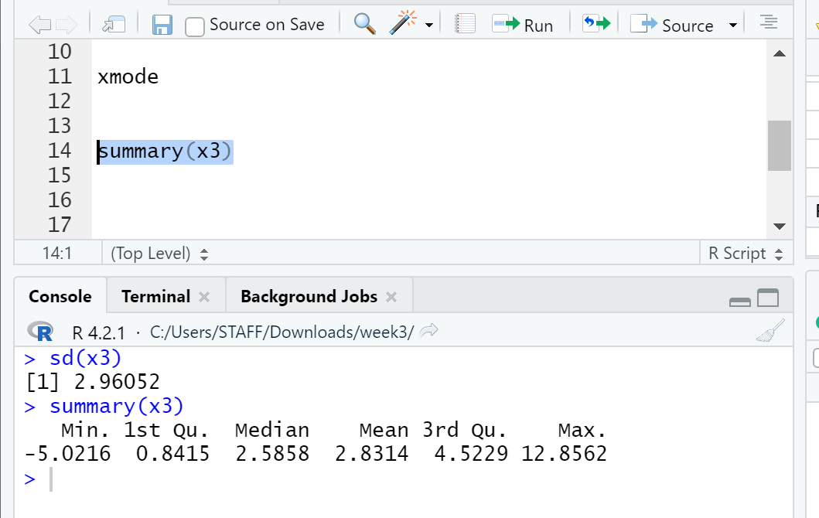

Range
The range of an observation variable is the difference of its largest and smallest data values. It is a measure of how far apart the entire data spreads in value.

max(x3)-min(x3)

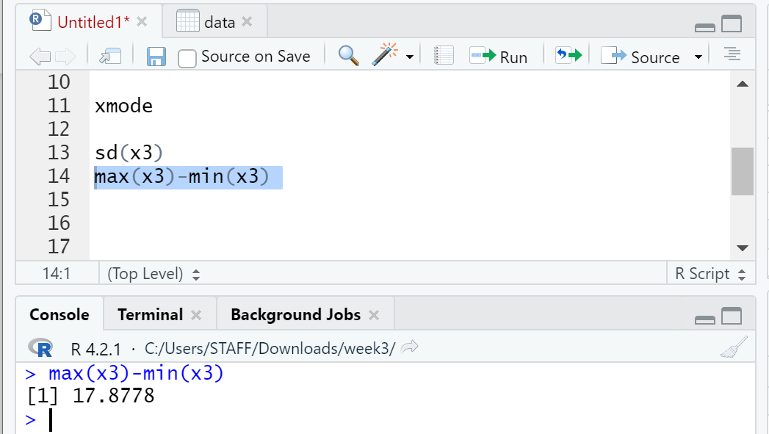

Interquartile Range
The interquartile range of an observation variable is the difference of its upper and lower quartiles. It is a measure of how far apart the middle portion of data spreads in value.

IQR(x3)

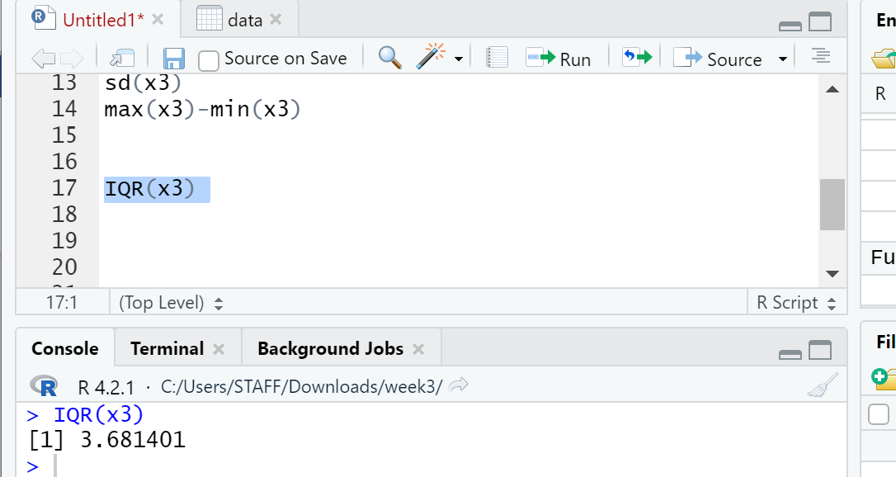

Box Plot
The box plot of an observation variable is a graphical representation based on its quartiles, as well as its smallest and largest values. It attempts to provide a visual shape of the data distribution.

Problem
Find the box plot of the eruption duration in the data set x3

boxplot(x3, horizontal=TRUE)

